Patrick Morley

Professor Holden-Gouveia

Linux Administration

Networking Lab

**Ubuntu:**

Ip addr show

Nmcli device show ens33

Netstat -lntu

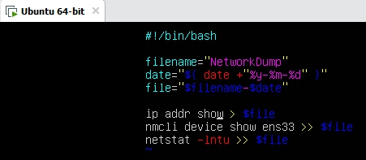

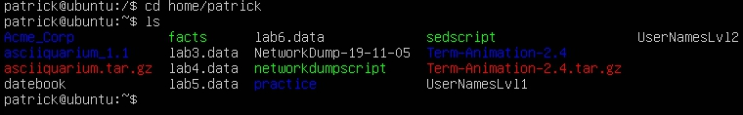

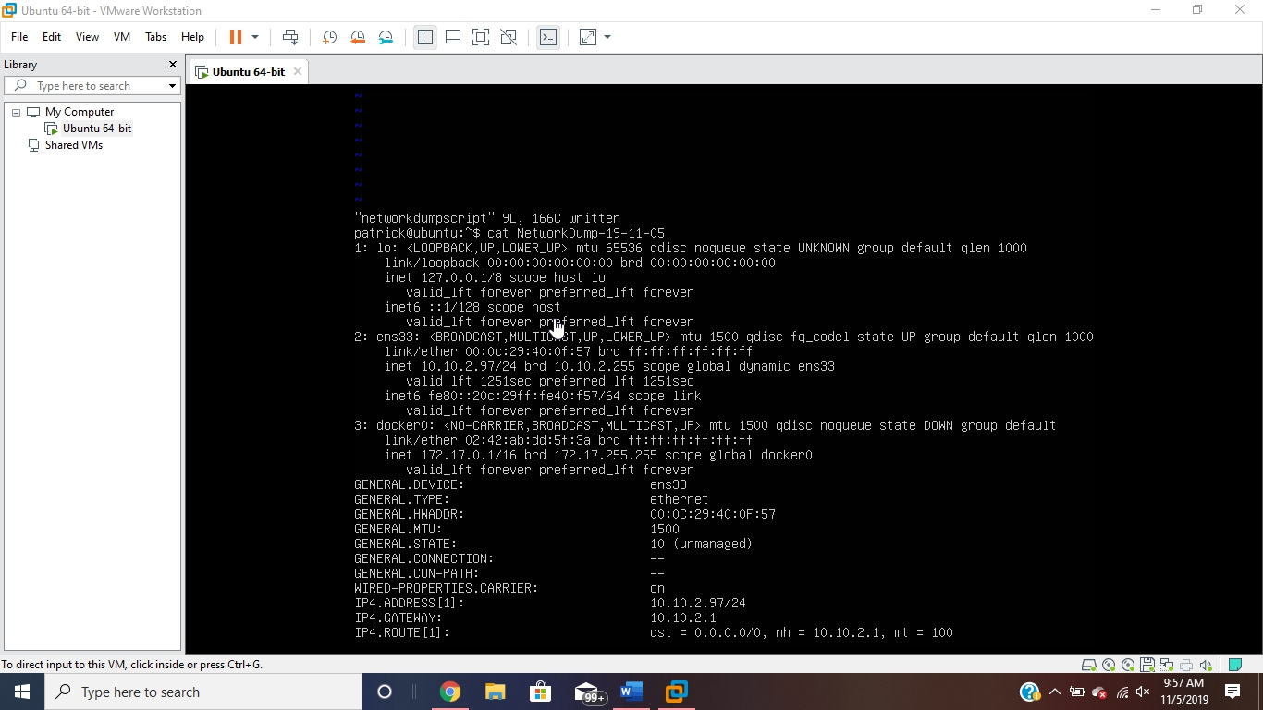

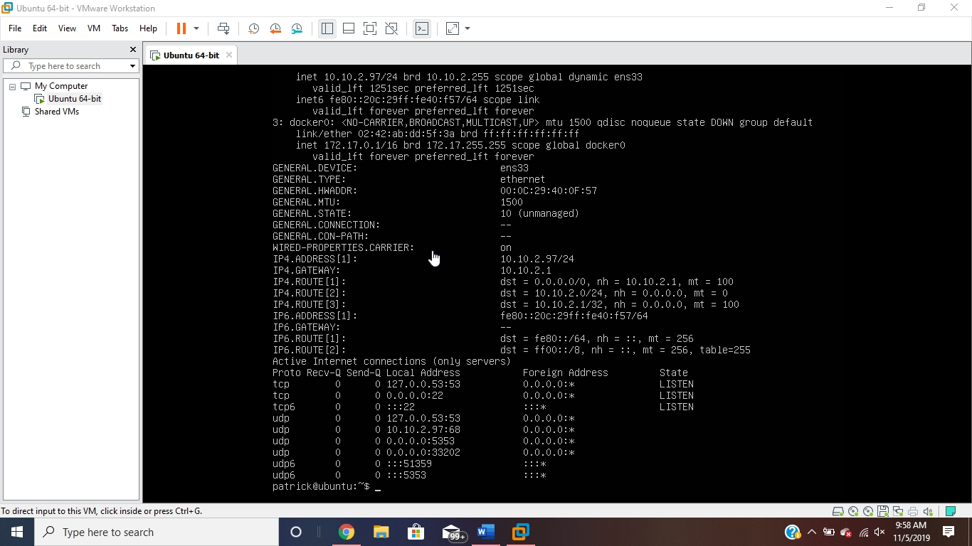

**CentOS:**

Ip address

Nmcli device show wlan0

Netstat -lntu

